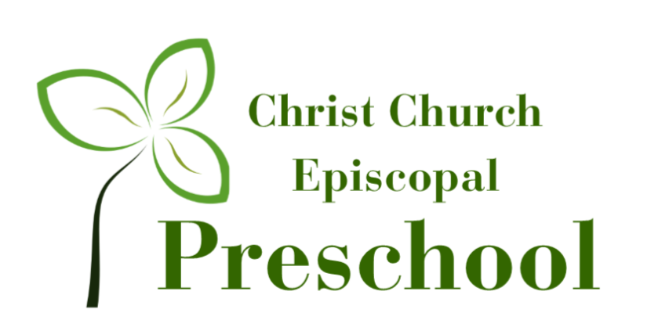

2022-2023 3/4's Preschool Curriculum
Children learn best through hands on experiences involving all of their senses. Each classroom and teacher provide age-appropriate activities to guide and motivate children toward learning. The majority of the learning is through large and small group interaction using Learning Centers: Dramatic Play, Blocks, Sensory, Manipulative, Science, Motor Development, Music & Movement, Listening and Art.

SEPTEMBER |  | Bible Theme: Made with Love Song: God Made Me
DATE- | 7-9 |  | 12-16 | 19-23 | 26-30
Literacy | Intro to HWT |  | Intro to HWT | L | F
Bible Story | God Loves Me |  | God Loves Me | God Loves Me | Creation
Weekly Theme | Welcome |  | Feelings | Apples | Creation
Scholastic | Welcome to School |  |  | Apples
Science: My Body Math: Counting to 10 Color: Red Shape: Square
Large Motor: Pedal a Tricycle Fine Motor: Holds scissors properly and cuts paper Dramatic Play: House

OCTOBER |  | Bible Theme: Super Hero’s Song: My God is so Big
DATE | 3-7 |  | 10-14 | 17-21 | 24-28
Literacy | E |  | H | T | I
Bible Story | Moses |  | Queen Esther | Joseph | Elisha
Weekly Theme | Fire and Safety |  | Autumn | Pumpkins | Halloween
Scholastic | Fire Safety |  |  | Pumpkins
Science: Autumn Math: Patterns Color: Yellow Shape: Circle
Large Motor: Jump with Both Feet Over a Barrier Fine Motor: Draws Circles Dramatic Play: Vet

NOVEMBER |  | Bible Theme: Helping Hands Song: Rise and Shine
DATE | 31-4 |  | 7-11 |  | 14-18 | 21-25
Literacy | U |  | C |  | O
Bible Story | Feeding of the 5000 |  | Healing the Blind Mane |  | Women Touching Jesus | BREAK
Weekly Theme | Sounds of Autumn |  | Community Helpers |  | Thanksgiving
Scholastic | We Are Thankful |  |  | Turkey
Science: Healthy Foods Math: Measuring Color: Red + Yellow = Orange Shapes: Triangle Language: Dictate a Story
Large Motor: Balance on One Foot Fine Motor: Rolls Play Dough with Fingers Dramatic Play: Farm Store

DECEMBER |  | Bible Theme: Birthday Bash Song: Angel in the Air
DATE | 28-2 |  | 5-9 |  | 12-16 | 19-23 | 26-30
Literacy | Q |  | G |  | S
Bible Theme | Angel & Mary |  | Jesus is Born |  | The Shepherds | BREAK | BREAK
Weekly Theme | Hibernation |  | Gingerbread |  | Christmas
Scholastic | Sleepy Bears |  |  | Holiday Traditions
Science: Magnets Math: Counting by 20 Color: Green Shape: Star Language: Rhyming
Large Motor: Hop on One Foot Fine Motor: Stack 12+ Blocks Dramatic Play: Baby Care

JANUARY |  | Bible Theme: Super Kids Song: Jesus Loves the Little Children
DATE | 2-6 |  | 9-13 | 16-20 | 23-27
Literacy | J |  | D | P | B
Bible Story | Wisemen |  | Jesus Lost | Boy King | Jesus and the Children
Weekly Theme | Snow & Ice |  | Snowmen | Penguins | Polar Animals
Scholastic | Winter Weather |  |  | Polar Habitat
Science: Winter and Ice Math: Spatial Relationships (up/down, etc...)
Color: Blue Shape: Rectangle Language: Alliteration
Large Motor: Throw a Ball at a Target Fine Motor: Use Eye Dropper Dramatic Play: Grocery Store

FEBRUARY |  | Bible Theme: Fantastic Friend Song: Zacchaeus
DATE | 30-3 |  | 6-10 | 13-17 | 20-24
Literacy | R |  | K | A | M
Bible Theme | Jesus & John- Baptism |  | Four Friends | 12 Disciples | Zacchaeus
Weekly Theme | Friendship |  | Valentine’s Day | Nursery Rhymes | Dinosaurs
Scholastic | Friendship |  |  | Dental Health
Science: Weather Math: Counting 5 Items
Color: Red + White= Pink Shape: Heart Language: Name Writing
Large Motor: Walk on Balance Beam Fine Motor: Cuts on a Straight-Line Dramatic Play: Flower Shop

MARCH |  | Bible Theme: Story Time with Jesus Song: The B-I-B-L-E
DATE | 27-3 |  | 6-10 | 13-17 |  | 20-24 | 27-31
Literacy | N |  | V | W |  | X
Bible Theme | The Good Samaritan |  | The Good Shepherd | The Lost Son |  | Noah’s Ark | BREAK
Weekly Theme | Weather |  | 5 Senses | Baby Animals |  | Farm Animals
Scholastic | Rainbows |  |  |  | Ladybugs
Science: Plants Math: Classification
Color: Brown Shape: Oval Language: Same and Different (visual discrimination)
Large Motor: Somersaults Fine Motor: Holds Writing Utensil with Fingers Dramatic Play: Post Office

APRIL |  | Bible Theme: God’s Animals Song: Jesus Loves Me
DATE | 3-7 |  | 10-14 | 17-21 | 24-28
Literacy | Y |  | Z | 1-3 | 3-7
Bible Theme | The Talking Donkey |  | Easter | Daniel and the Lions | Lost Sheep
Weekly Theme | Plants |  | Signs of Spring | Butterflies | Farm Animals
Scholastic | Plants |  |  | Keeping the Earth Clean
Science: Sink and Float Math: One-to-One Correspondence
Color: Purple Shape: Diamond Language: Story Comprehension
Large Motor: Walks on a Line Fine Motor: Cuts on a Curved Line Dramatic Play: Hospital

MAY
Bible Theme: Water Wonders Song: Butterfly Song
DATE | 2-6 | 9-13 | 16-20 | 23-27
Re | 7-10 | Review | Review | Review
Bible Story | Jonah and the Whale | Jesus Walks on Water | Catching of Fish | Jesus Loves Me
Weekly Theme | Creepy Crawlies | Sea Life | Beach Time | Summer Fun
Scholastic | Baby Shark |  | Summer Safety
Science: Dirt, Rocks and Bugs Math: 3 Part Story Sequencing
Color: Black Shape: Octagon Language: What is the Order? (Attention to detail)
Large Motor: Gallop Fine Motor: Tracing Dramatic Play: Ice Cream Shop
