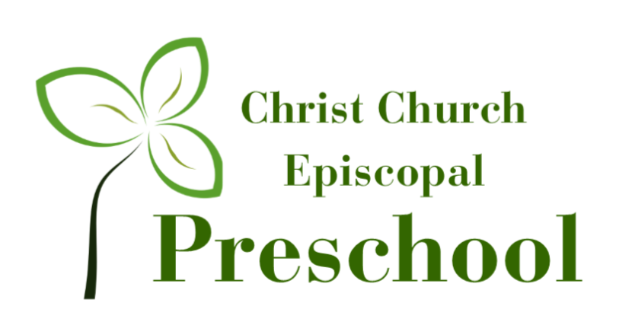

2022-2023 Pre-K Curriculum
Children learn best through hands on experiences involving all of their senses. Each classroom and teacher provide age-appropriate activities to guide and motivate children toward learning. The majority of the learning is through large and small group interaction using Learning Centers: Dramatic Play, Blocks, Sensory, Manipulative, Science, Motor Development, Music & Movement, Listening and Art.

SEPTEMBER |  | Bible Theme: Made with Love Song: God Made Me
DATE | 7-9 |  | 12-16 | 19-23 | 26-30
Literacy | Intro to HWT |  | Intro to HWT | L | F
Bible Story | God Loves Me |  | God Loves Me | God Loves Me | Creation
Weekly Theme | Back to School |  | Feelings | Apples | Creation
Scholastic | Wash Your Hands |  | You Are Special | I Try My Best | Backyard Animals
Science: What Scientists Do Math: Counting Color: Red Shape: Square Language: Copy Sound Rhythms
Large Motor: Climbing Vertically on Structures Fine Motor: Roll Play dough Flat with Rolling Pin Dramatic Play: Office

OCTOBER |  | Bible Theme: Super Hero’s Song: My God is so Big
DATE | 3-7 |  | 10-14 | 17-21 | 24-28
Literacy | E |  | H | T | I
Bible Story | Moses |  | Queen Esther | Joseph | Elisha
Weekly Theme | Community Helpers |  | Pumpkins | Autumn Leaves | Halloween
Scholastic | Fire Safety |  | Pumpkins | Autumn Changes | Bats
Science: Spiders Math: Number Sense Color: Yellow Shape: Circle Language: Rhyming Words
Large Motor: Hop on One Foot & Change Feet Fine Motor: Write Name (Uppercase) Dramatic Play: Farm Store

NOVEMBER |  | Bible Theme: Helping Hands Song: Rise and Shine
DATE | 31-4 |  | 7-11 | 14-18 | 21-25
Literacy | U |  | C | O
Bible Story | Feeding of the 5000 |  | Healing of the Blind Man | Women Touching Jesus | BREAK
Weekly Theme | Forest Animals |  | Give Thanks | Thanksgiving
Scholastic | NA |  | Veteran’s Day | Thanksgiving
Science: Autumn Math: One-to-One Correspondence Color: Red + Yellow = Orange Shape: Triangle
Language: Phonics Large Motor: Kick Ball at Target Fine Motor: Cut Simple Shapes Dramatic Play: Veterinary

DECEMBER |  | Bible Theme: Birthday Bash Song: Angel in the Air
DATE | 28-2 |  | 5-9 | 12-16 | 19-23 | 26-30
Literacy | Q |  | G | S
Bible Theme | Angel & Mary |  | Jesus is Born | The Shepherds | BREAK | BREAK
Weekly Theme | Hibernation |  | Gingerbread | Christmas
Scholastic | Hibernation |  | Native American  Heritage Month | Reindeer
Science: Hibernation Math: Sequencing Color: Green Shape: Star Language: Phonics
Large Motor: Hop Forward on One Foot Fine Motor: Strings Small Beads Dramatic Play: Santa’s Workshop

JANUARY |  | Bible Story: Super Kids Song: Jesus Loves the Little Children
DATE | 2-6 |  | 9-13 | 16-20 | 23-27
Literacy | J |  | D | P | B
Bible Story | Wisemen |  | Jesus Lost | Boy King | Jesus and the Children
Weekly Theme | Snowmen |  | Snow & Ice | Winter Animals | Winter Tracks
Scholastic | Snowmen |  | Dr. King | Penguins | Bear Scientist
Science: Science Sound Math: Addition Color: Blue Shape: Rectangle Language: Story Comprehension
Large Motor: Bounce Ball (dribble) in Place Fine Motor: Fold and Cut Paper Dramatic Play: Science Lab

FEBRUARY
Bible Theme: Fantastic Friends Song: Zacchaeus
DATE | 30-3 | 6-10 | 13-17 | 20-24
Literacy | R | K | A | M
Bible Story | Jesus & John- Baptism | Four Friends | 12 Disciples | Zacchaeus
Weekly Theme | Friendship | Valentine’s Day | Dinosaurs | Nursery Rhymes
Scholastic | Groundhog Day | Black History Month | President’s Day | Dental Health
Science: Meet a Scientist Math: Subtraction Color: Red + White = Pink Shape: Heart Language: Story Comprehension
Large Motor: Walk on Balance Beam Unassisted Fine Motor: Copy Shapes Dramatic Play: Flower Shop

MARCH
Bible Theme: Story Time with Jesus Song: The B-I-B-L-E
DATE | 27-3 | 6-10 | 13-17 | 20-24 | 27-31
Literacy | N | V | W | X
Bible Story | The Good Samaritan | The Good Shepherd | The Lost Son | Noah’s Ark | BREAK
Weekly Theme | Weather | Butterflies | Spring | Animals
Scholastic | Spring Weather | Read Across America | St. Patrick’s Day | Animal Homes
Science: Baby Animals Math: Measurement Color: Brown Shape: Oval Language: Sight Words
Large Motor: Jump Forward from Standing Fine Motor: Weaving Dramatic Play: Grocery Store

APRIL
Bible Theme: God’s Animals Song: Jesus Loves Me
DATE | 3-7 | 10-14 | 17-21 | 24-28
Literacy | Y | Z | 1-3 | 3-7
Bible Story | The Talking Donkey | Easter | Daniel and the Lions | The Lost Sheep
Weekly Theme | Easter | Planting | Earth Day | Bugs
Scholastic | A Chick Hatches | Plants | Earth Day | Insects
Science: Engineering Math: 4 Part Story Sequencing Color: Purple Shape: Diamond Language: Sight Words
Large Motor: Skip Fine Motor: Draws Self Portrait Dramatic Play: Coffee Shop

MAY
Bible Theme: Water Wonders Song: Butterfly Song
DATE | 2-6 | 9-13 | 16-20 | 23-27
Literacy | 7-10 | Review | Review | Review
Bible Story | Jonah and the Whale | Jesus Walks on Water | Catching of Fish | Jesus Loves Me
Literacy | 7-10 | Review | Review | Review
Weekly Theme | Nature | Sea Life | Beach Time | Summer Fun
Scholastic | Push and Pull | Bubble Science | Hermit Crab | Summer Safety
Science: How Animals Show They’re Happy Math: Algebra Color: Black Shape: Octagon
Language: Matching Upper and Lowercase Letters Large Motor: Catches a Small Ball Thrown Overhead
Fine Motor: Begins Tying Knots and Lace Dramatic Play: Camping
